CONSUMER GUIDE TO AGENCY RELATIONSHIPS

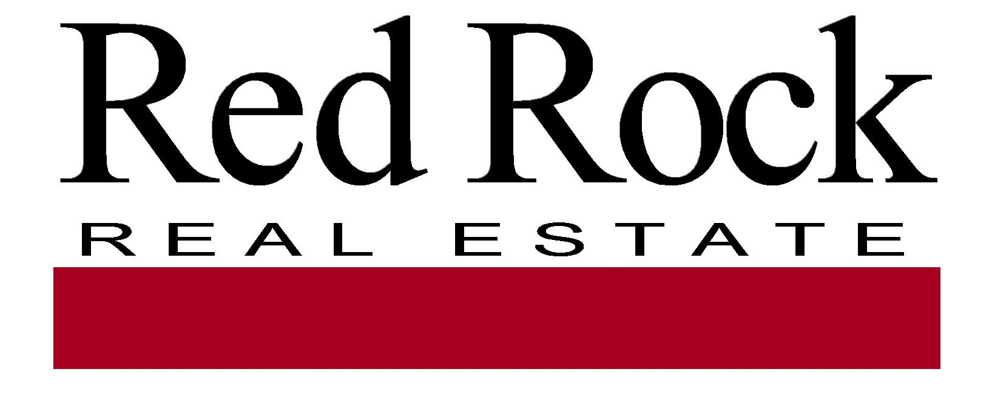


We are pleased you have selected RED ROCK REAL ESTATE to help you with your real estate needs. Whether you are selling, buying or leasing real estate RED ROCK REAL ESTATE can provide you with expertise and assistance. Because this may be the largest financial transaction you will enter into, it is important to understand the role of the agents and brokers with whom you are working. Below is some information that explains the various services agents can offer and their options for working with you:

Representing the Sellers
Most sellers of real estate choose to list their home for sale with a real estate brokerage. When they do so, they sign a listing agreement that authorizes the brokerage and the listing agent to represent their interests. As the seller’s agent, the brokerage and listing agent must: follow the seller’s lawful instructions, be loyal to the seller, promote the seller’s best interests, disclose material facts to the seller, maintain confidential information, act with reasonable skill and care and, account for any money they handle in the transaction. In rare circumstances a listing broker may offer “subagency” to other brokerages which would also represent the seller’s interests and owe the seller these same duties.

Representing Buyers
When purchasing real estate, buyers usually choose to work with a real estate agent as well. Often the buyers want to be represented in the transaction. This is referred to as buyer’s agency. A brokerage and agent that agree to represent a buyer’s interest in a transaction must: follow the buyer’s lawful instructions, be loyal to the buyer, promote the buyer’s best interests, disclose material facts to the buyer, maintain confidential information and, account for any money they handle in the transaction.

Dual Agency
Occasionally the same agent and brokerage who represents the seller also represents the buyer. This is referred to as dual agency. When a brokerage and its agents become “dual agents”, they must maintain a neutral position in the transaction. They may not advocate the position of one client over the best interests of the other client, or disclose any confidential information to the other party without written consent.

Representing Both the Buyer & Seller
On occasion, the buyer and seller will each be represented by two different agents from the same brokerage. In this case the agents may each represent the best interest of their respective clients. Or, depending on company policy, the agents may both act as dual agents and remain neutral in the transaction. When either of the above occurs, the brokerage will be considered a dual agent. As a dual agent the brokerage and its managers will maintain a neutral position and cannot advocate for the position of one client over another. The brokerage will also protect the confidentiality of all parties.

For more information on agency law in Ohio you can also contact the Ohio Division of Real Estate & Professional Licensing at (614) 466-4100, or on their website www.com.state.oh.us.

Working With RED ROCK REAL ESTATE

RED ROCK REAL ESTATE does offer representation to both buyers and sellers. Therefore the potential exists for one agent to represent a buyer who wishes to purchase property listed with another agent in our company. If this occurs each agent will represent their own client, but RED ROCK REAL ESTATE and its managers will act as a dual agent.
This means the brokerage and its managers will maintain a neutral position and not take any actions that will favor one side over the other. RED ROCK REAL ESTATE will still supervise both agents to assure that their respective clients are being fully represented and will protect the parties’ confidential information.

In the event that both the buyer and seller are represented by the same agent, that agent and RED ROCK REAL ESTATE will act as a dual agent but only if both parties agree. As a dual agent they will treat both parties honestly, prepare and present offers at the direction of the parties, and help the parties fulfill the terms of any contract. They will not, however, disclose any confidential information that would place one party at an advantage over the other or advocate or negotiate to the detriment of either party.

If dual agency occurs you will be asked to consent to that in writing. If you do not agree to your agent acting as a dual agent, you can ask that another agent in our company be assigned to represent you or you can seek representation from another brokerage.

As a buyer you may also choose to represent yourself on properties RED ROCK REAL ESTATE has listed. In that instance RED ROCK REAL ESTATE will represent the seller and you would represent your own best interests. Because the listing agent has a duty of full disclosure to the seller you should not share any information with the listing agent that you would not want the seller to know.

Working With Other Brokerages

When RED ROCK REAL ESTATE lists property for sale it also cooperates with, and offers compensation to, other brokerages that represent buyers. RED ROCK REAL ESTATE does reserve the right, in some instances, to vary the compensation it offers to other brokerages. As a seller, you should understand that just because RED ROCK REAL ESTATE shares a fee with a brokerage representing the buyer, it does not mean that you will be represented by that brokerage. Instead that company will be looking out for the buyer and RED ROCK REAL ESTATE will be representing your interests. When acting as a buyer’s agent, RED ROCK REAL ESTATE also accepts compensation offered by the listing broker. If the property is not listed with any broker, or the listing broker does not offer compensation, we will attempt to negotiate for a seller-paid fee.

Fair Housing Statement
It is illegal, pursuant to the Ohio Fair Housing Law, division (H) of Section 4112.02 of the Revised Code and the Federal Fair Housing Law, 42 U.S.C.A. 3601, as amended, to refuse to sell, transfer, assign, rent, lease, sublease or finance housing accommodations, refuse to negotiate for the sale or rental of housing accommodations, or otherwise deny or make unavailable housing accommodations because of race, color, religion, sex, familial status as defined in Section 4112.01 of the Revised Code, ancestry, military status as defined in that section, disability as defined in that section, or national origin or to so discriminate in advertising the sale or rental of housing, in the financing of housing, or in the provision of real estate brokerage services. It is also illegal, for profit, to induce or attempt to induce a person to sell or rent a dwelling by representations regarding the entry into the neighborhood of a person or persons belonging to one of the protected classes.

We hope you find this information to be helpful to you as you begin your real estate transaction. When you are ready to enter into a transaction, you will be given an Agency Disclosure Statement that specifically identifies the role of the agents and brokerages. Please ask questions if there is anything you do not understand. Because it is important that you have this information Ohio law requires that we ask you to sign below, acknowledging receipt of this consumer guide. Your signature will not obligate you to work with our company if you do not choose to do so.

__________________________________ ________________________________________
Name (Please Print) Name (Please Print)

__________________________________ ________________________________________
Signature Date Signature Date

